College Algebra – Review for Test 2

1. Sketch the graph of the following functions. Use function notation to calculate
three points on the graph. State the domain and range of the functions and also
the equation of the asymptote. For (c) use 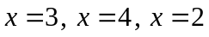 .

(a) 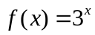 (b) 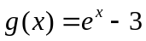 (c) 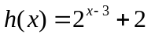

2. Sketch the graph of the following functions. Use function notation to calculate
three points on the graph. State the domain and range of the functions and also
the equation of the asymptote. For (b) use 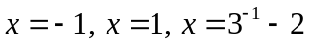

(a) 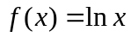 (b) 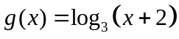 (c) 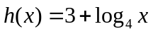

3. Rewrite each expression into the appropriate form and then simplify without
using a calculator (do not introduce a variable).

(a) 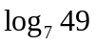 (b) 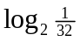 (c) 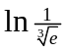

4. Condense the following expression into a single logarithm.

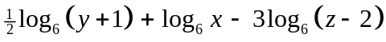

5. Expand the logarithm as much as possible.

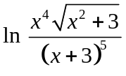

6. Find the domain and the equation of the asymptote for the functions.

(a) 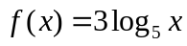 (b) 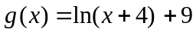

7. Solve the following equations. Find the exact solution first. If the answer contains
a logarithm or the number then use a calculator to approximate the answers to
two decimal places. For logarithmic equations, verify that the solution is in the
domain of each logarithm in the equation.

(a) 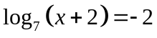

(b) 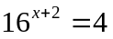

(c) 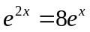

(d) 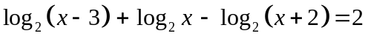

(e) 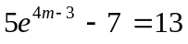

(f) 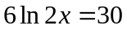

(g) 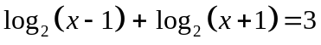

(h) 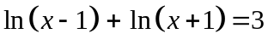

(i) 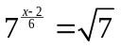

(j) 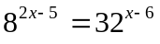

8. A certain radioactive substance decays according to the formula 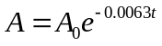,
where 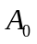is the initial amount of the substance and is the time in days.
Approximate the half-life of the substance.

9. Based on present birth and death rates, the population of Kenya is expected to
increase according to the formula 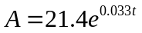, with A in millions and 
corresponding to 1989. How many years will it take for the population to double?

10. A pond is stocked with 1000 trout. Three months later, it is estimated that 600
remain. Find a formula of the form 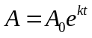 that can be used to estimate the
number of trout remaining after months.

11. Suppose that the number of bacteria present in a certain culture after minutes is
given by the equation 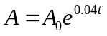, where represents the initial number of
bacteria. How long would it take for the bacteria count to grow from 500 to 2000?

12. Suppose that the present population of a city is 50,000 and suppose that the
equation 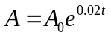can be used to estimate future populations. Estimate the
population of that city in 20 years.

13. Xanax is a tranquilizer used in the short-term relief of symptoms of anxiety. Its
half-life in the bloodstream is 36 hours. How long will it take for Xanax to decay
to 90% of the original dosage?

14. Find the equation of 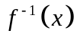: (a) 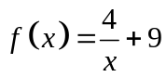 (b) 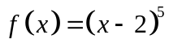
15. Determine whether 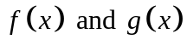 are inverses:

(a) 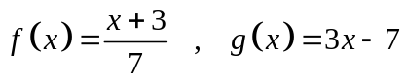 (b) 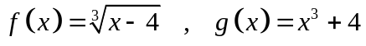

Answers

1. (a) (b)
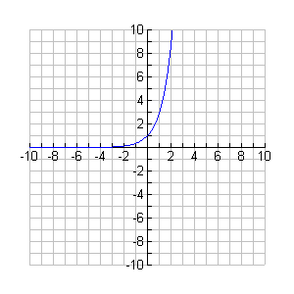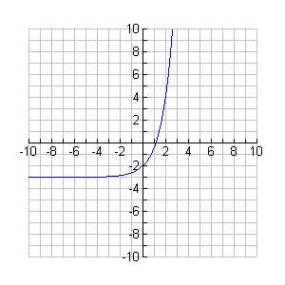

(c) 2. (a)
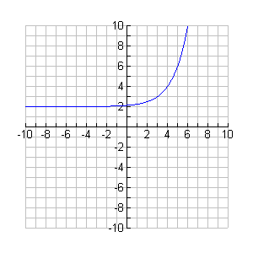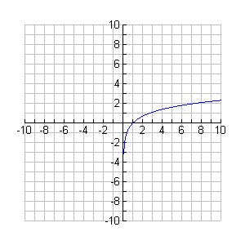

2 (b) (c)
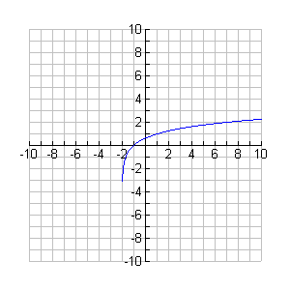
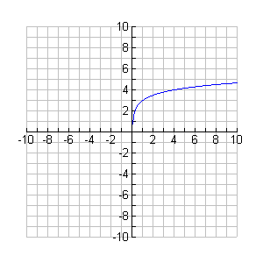

3. (a) 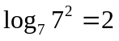 (b) 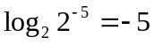 (c) 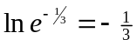

4. 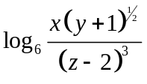

5. 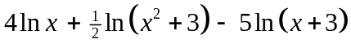

6. (a) 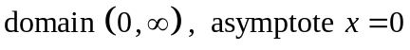 (b) 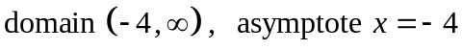

7. (a) 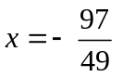

(b) 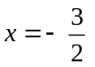

(c) 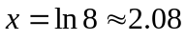

(d) 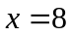

(e) 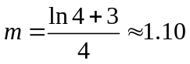

(f) 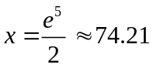

(g) 

(h) 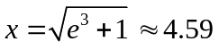

(i) 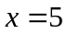

8. 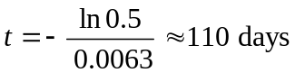

9. 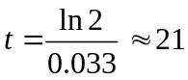 years

10. 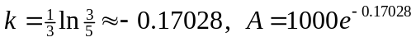

11. 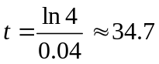 minutes

12. 74,591

13. 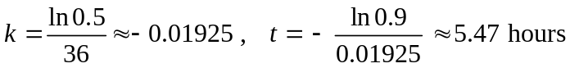

14. (a) 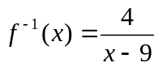 (b) 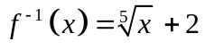

15. (a) no, not inverses (b) yes, inverses

